# Racecar Test 1

A bitbot has bene programmed so that it follows a light. Which type of code construct takes a different path through the program depending upon the light reading?

A. Selection

B. Iteration

C. Sequence

D. Assignment

ANSWER: B

A sensor takes analogue readings. Which feature describes an analogue reading?

A. Analogue readings are continuous

B. Analogue readings can be understood by a computer

C. Analogue readings have to be taken manually by a human

D. Analogue readings can only record data as 1 or 0

ANSWER: A

The light sensor on the bitbot takes a reading in a brightly lit room. The sensor returns the maximum value that it can return. What value does it return?

A. 1024

B. 1023

C. 800

D. 1

ANSWER: B

The first three steps in the program below will always run in the same order. What is this an example of?

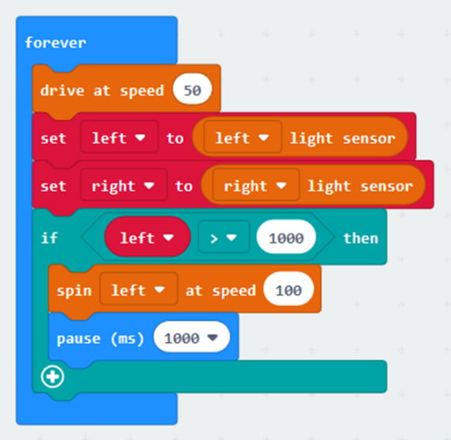

A. Selection

B. Sequence

C. Iteration

D. Assignment

ANSWER: B

Which of the following is not a feature of a vector graphic?

A. It is made up of individual dots of colour called pixels

B. It can be resized with no loss of quality

C. It has a smaller file size than a bitmap

D. Logos are often created as vector graphics

ANSWER: A

What is a car production line an example of?

A. Prototyping

B. Mass production

C. Iterative development

D. Testing

ANSWER: B

A car manufacturer is developing a new car. Different people are designing different parts of the vehicle at the same time. What is this process called?

A. Iterative development

B. Modular design

C. Systematic design

D. Abstraction

ANSWER: B

A new car has been designed so that it can drive without any human input. What type of vehicle is this?

A. Autonomous

B. Algorithmic

C. Automatic

D. Intelligent

ANSWER: A

Why is it necessary to test your code once it has been developed?

A. To try to identify any faults so that they can be fixed

B. To prove that it works

C. To gain a sense of achievement

D. To break the system

ANSWER: A

A student is building a new device which uses different attachments to work with the bit: bot. They have decided to split the overall task down into a number of small tasks. What is this process known as?

A. Abstraction

B. Development

C. Distribution

D. Decomposition

ANSWER: D

Which of the following is a type of short range wireless communication?

A. Bluefoot

B. Cat 6

C. Cat 5

D. Bluetooth

ANSWER: B

Rob wishes to send data wirelessly between two microbits. Where will he find the command to set the sending and receiving channel to 1?

A. Input

B. Radio

C. Logic

D. Variables

ANSWER: B

Laura has found that her two microbits are receiving corrupt data as a third device is using the same channel. To fix this she needs to change the channel. How many different channels does the microbit have?

A. 84

B. 83

C. 1

D. 2

ANSWER: A

What number will be transmitted if directionTX is less than 32?

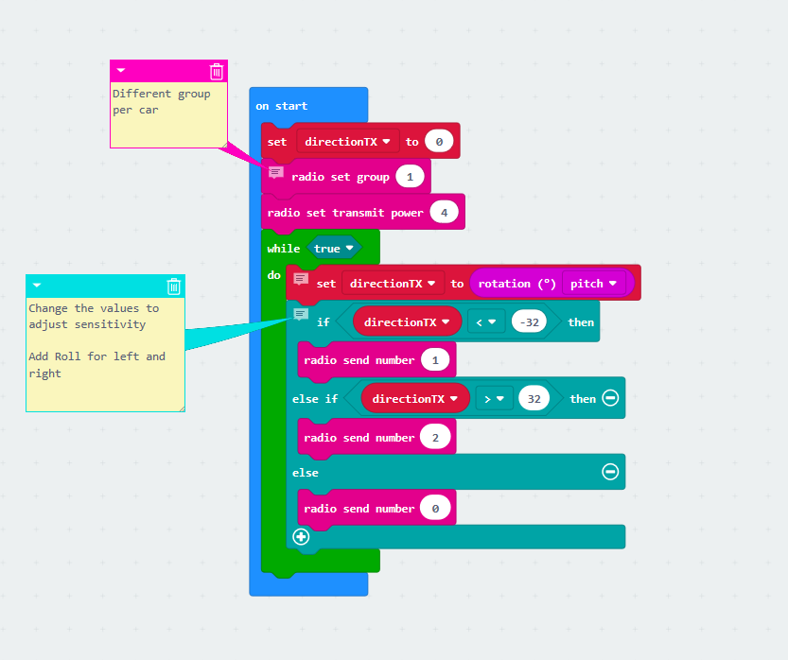

A. 0

B. 1

C. 2

D. 4

ANSWER: A

The code below has been created so that the bit:bot follows a torch light. The bitbot is being tested in a very bright room so the sensitivity needs to be adjusted. Which value should be changed?

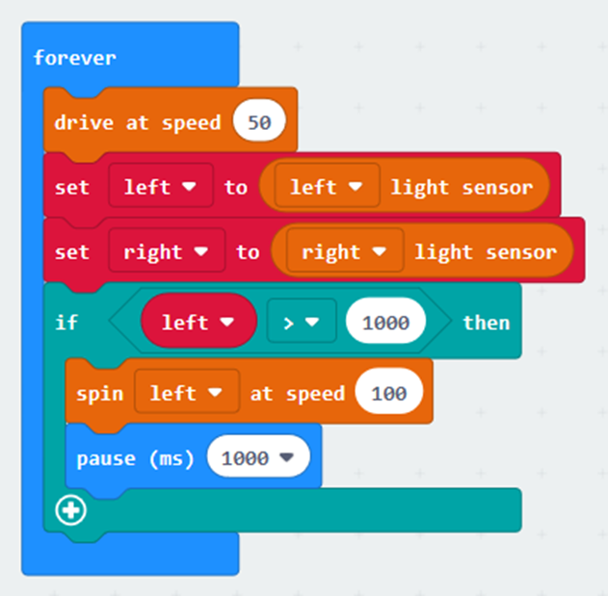

A. left > 1000

B. drive at speed 50

C. pause (ms) 1000

D. spin left at speed 100

ANSWER: A

Which of the following images is a bitmap?

1. 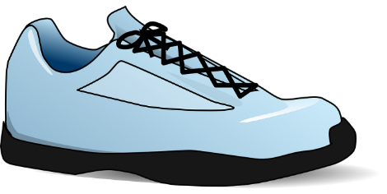
2. 
3. 
4. 

ANSWER: B

Which of the following is one of the most important parts of a brand?

A. The product design

B. The product functionality

C. The logo

D. What the offices look like

ANSWER: C

One method of developing a new product is to build an initial trial version, test it, refine it. This process continues until the final product is produced. What is this process known as?

A. Abstraction

B. Sequence

C. Prototyping

D. Developing

ANSWER: C

The code below has been written to transmit data between two micro:bits. The second microbit is too far away to receive the data. How could the code be adjusted?

Snippet 1

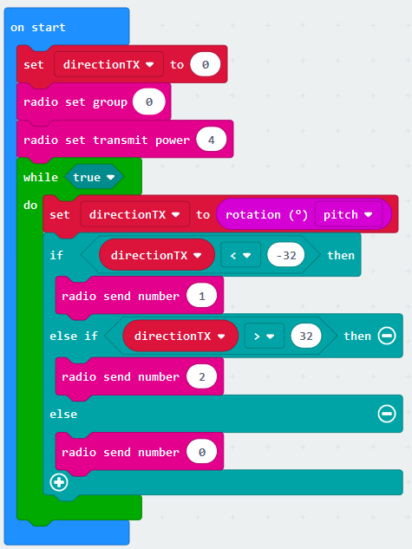Snippet 2

A. Change the radio set group to 1 in snippet 2

B. Change the radio set group to 2 in snippet 2

C. Increase the radio set transmit power to 7 in snippet 2

D. Decrease the radio set transmit power to 2 in snippet 2

ANSWER: C

What colour blocks are the ones found within the sensors category?

A. Blue

B. Yellow

C. Turquoise

D. Orange

ANSWER: D